## Time Table

**Time Table:**

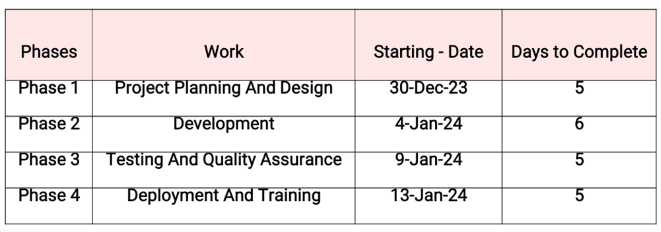

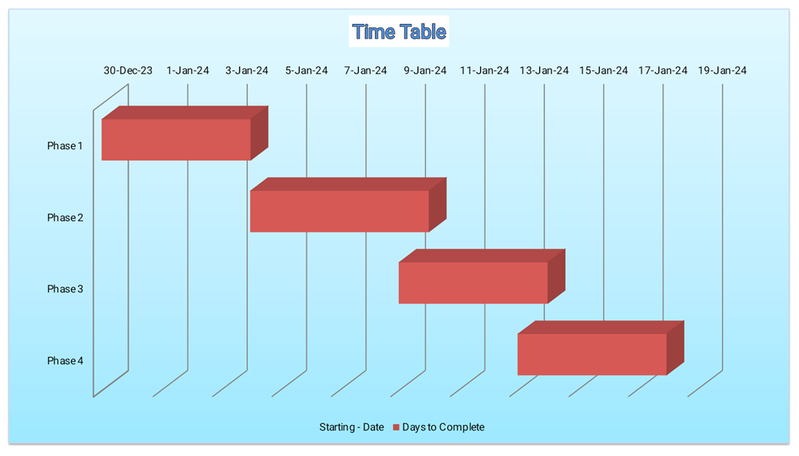

**Budget**

The budget for EmpOps is a comprehensive financial plan that reflects the commitment to developing, implementing, and maintaining a Robust and Effective Employee Management System.

This budget needs to be regularly reviewed and adjusted based on project progress, changing requirements, and organizational needs.

|  |  |  |
| --- | --- | --- |
| **Category** | **Description** | **Estimated Cost (ETB)** |
| **Personnel Costs** | Salaries and compensation for development team | **100,000** |
| **Hardware Acquisitions** | Servers, networking infrastructure | **100,000** |
| **Software Licenses** | Development tools, operating systems | **10,000** |
| **Training Expenses** | Workshops, documentation preparation | **10,000** |
| **DevOps Integration** | Jenkins, Git, Docker, Github integration | **20,000** |
| **Continuous Improvement** | Ongoing updates and improvements | **15,000** |
| **Marketing and Communication** | Promotional efforts | **10,000** |
| **Support and Maintenance** | Support team, ongoing maintenance | **30,000** |
| **Contingency** | Unforeseen expenses and scope changes | **15,000** |
| **Training Material and Resources** | Creation and distribution | **10,000** |
| **Testing and Quality Assurance** | Bug identification and resolution | **20,000** |
| **Documentation and Reporting** | Preparation of materials and reports | **5,000** |
| **Post-Implementation Review** | Assessments and improvements | **10,000** |
| **License Renewals** | Software license renewals | **5,000** |
| **Total Budget** | - | **360,000 ETB** |